Table of Contents

RESOURCES 3

Access GitHub’s IHTSDO/ISAAC project 3

Ensure have JDK 1.7 or JDK 1.8 installed on system 3

Ensure have Maven 3.0.5 installed on system 3

Subfolders found under IHTSDO/ISAAC Git Project on GitHub to download: 3

Download a Berkeley Database 3

General Setup 3

Setup your settings.xml file 3

Verify the validity of the reference to tools.jar in ttk-mmb.pom 4

Setup Projects in IDE 4

Eclipse Workspace Setup 4

NetBeans 4

IntelliJ 4

Command Line 4

Create a Git local repository of ISAAC 4

Import local Git repository into IDE 6

Eclipse 6

NetBeans 8

IntelliJ 8

Command Line 8

Build two Maven projects 8

Eclipse 8

NetBeans 10

IntelliJ 10

Command Line 10

Install Glassfish 4.0 10

Eclipse 10

NetBeans 13

IntelliJ 13

Command Line 13

Deploy Berkeley Database onto Server 13

Start Glassfish Server 13

Eclipse 13

NetBeans 14

IntelliJ 14

Command Line 14

Configure Glassfish Properties 14

Deploy SIM Rest Server 15

Via AutoDeploy 15

Via Glassfish Administrator Web Page 15

Test Deployment 16

# RESOURCES

## Access GitHub’s IHTSDO/ISAAC project

1. Create a GitHub account at <http://github.com>
2. Request access to the IHTSDO /ISAAC Project on GitHub from a project administrator
   1. Currently, only Rory Davidson may provide you with permissions to the project
3. Access IHTSDO/ISAAC project at: <https://github.com/IHTSDO/ISAAC>

## Ensure have JDK 1.7 or JDK 1.8 installed on system

1. Download from <http://www.oracle.com/technetwork/java/javase/downloads/index.html>
2. Install as instructed

## Ensure have Maven 3.0.5 installed on system

1. Download from <http://maven.apache.org/download.cgi>
2. Install as instructed

## Subfolders found under IHTSDO/ISAAC Git Project on GitHub to download:

1. TK3 (Toolkit 3):
2. Contains the refactored core libraries
3. Contains updated Icons libraries
4. Does not contain GUI elements as the existing workbench GUI has been removed based on the architecture review’s recommendations
5. (SIM) Simple Integrated Model
6. Contains a simple event-driven document model for representing patient records

## Download a Berkeley Database

1. <To Be Completed>

# General Setup

## Setup your settings.xml file

1. Pull settings.xml file from <ISAAC_GIT_PROJECT_HOME>/resources/ folder
2. Replace <username> and <password> with your VA-Archiva credentials

…..

<servers>

<server>

<id>maestro</id>

<username>VA-ARCHIVA_USER_NAME</username>

<password>VA-ARCHIVA_USER _PASSWORD</password>

</server>

</servers>

…..

1. Define your local repository

…..

</servers>

<localRepository>

FULL_REPOSITORY_PATH (e.g. C:/Code/.m2/repo)

</localRepository>

<mirrors>

…..

## Verify the validity of the reference to tools.jar in ttk-mmb.pom

If have error in the pom line: <systemPath>${java.home}/../lib/tools.jar</systemPath>

where the artifact “maven-jaxb-schemagen-plugin” is defined

1. Use env.JAVA_HOME property
   1. Set the JAVA_HOME environment property on your system
   2. Change the property to <systemPath >${env.JAVA_HOME}</systemPath >
2. Hard-Code tools.jar location
   1. <systemPath>C:\Program Files\Java\jdk1.7.0_45\lib\tools.jar</systemPath>

# Setup Projects in IDE

## Eclipse Workspace Setup

1. Via **Windows-Preferences**, ensure **Java-Installed JREs** version is using latest jdk
2. Via **Windows-Preferences**, ensure **Maven-Installations** version is using local maven 3.0.5
3. Via **Windows-Preferences**, ensure **Maven-User Settings** has the User Settings pointing to the proper settings.xml file updated in General Setup portion of this document

## NetBeans

## IntelliJ

## Command Line

# Create a Git local repository of ISAAC

Demonstrated for Windows via Windows GitHub client

1. Goto <https://github.com/IHTSDO/ISAAC>
2. Select ‘Clone in Desktop’ button at lower-right

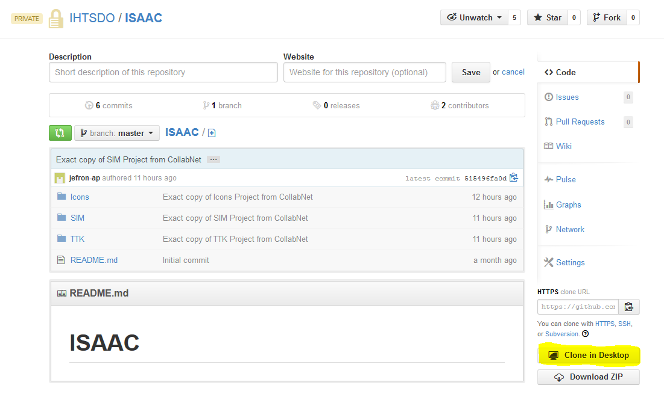

1. Opens GitHub client
2. Content will download
3. Once done, GitHub client will look like this

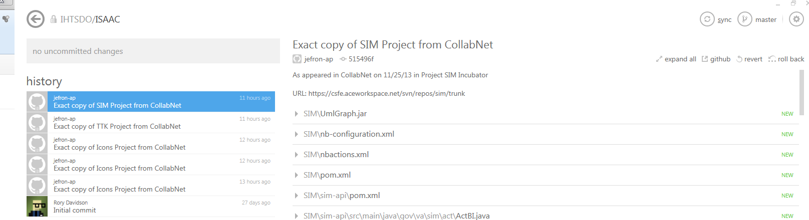

1. Locate local repository
   1. Click on settings button
   2. Select **open in explorer** option
   3. Explorer opens in directory containing local Git repository

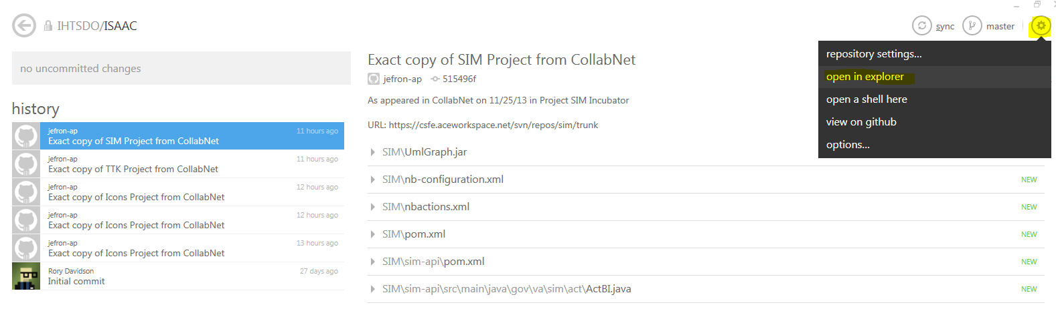

# Import local Git repository into IDE

## Eclipse

1. Select **File-Import**
2. Select **Maven-Existing** Maven Project option

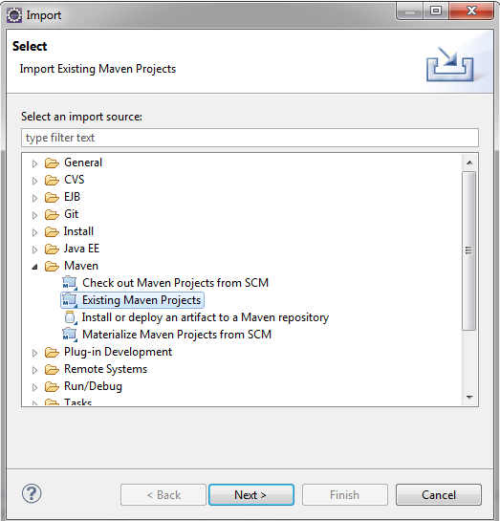

1. Point Root Directory to ISAAC’s local GitHub repository

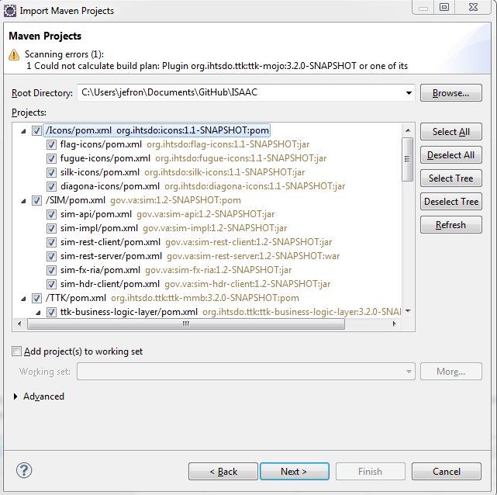

1. Once project finished loading up, select **Next** button
2. Even if **Setup Maven plugin connectors** shows errors, select **Finish** button

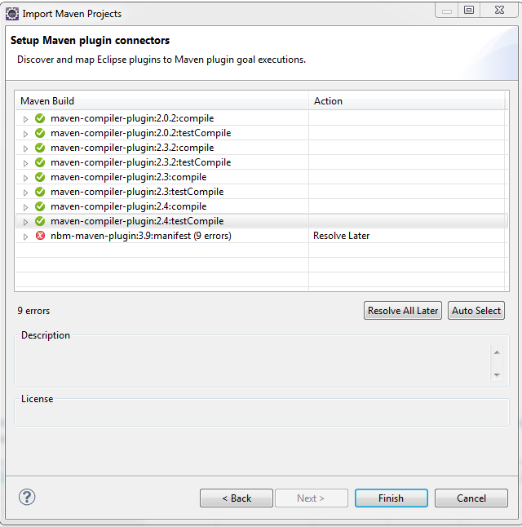

1. Select **OK** button if warning of build errors dialog box shows

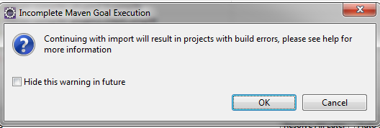

1. Wait for project to import, will import Maven dependent artifacts to local Maven repository
2. No action to take when **Auto share git projects** dialog box is displayed

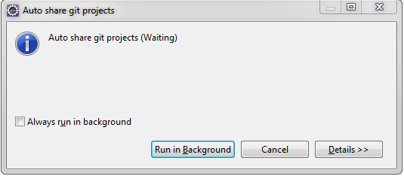

## NetBeans

## IntelliJ

## Command Line

# Build two Maven projects

1. TTK
2. SIM

## Eclipse

1. Create Run Configurations for each separate project
   1. Select **Run-Run Configurations** from Menu
   2. For each project
      1. Double click **Maven Build** option
      2. Name configuration
      3. Select Workspace
      4. Enter “-e clean install” for Goals
      5. If using JDK1.8, set “java8” for Profiles
         1. For TTK only
         2. If building with jdk 1.8, profile needs to be “java8” to enable 1.8 source compatibility
      6. Save by selecting **Apply** button
   3. Close
   4. TTK Run Configuration (select maven ttk-mmb project)

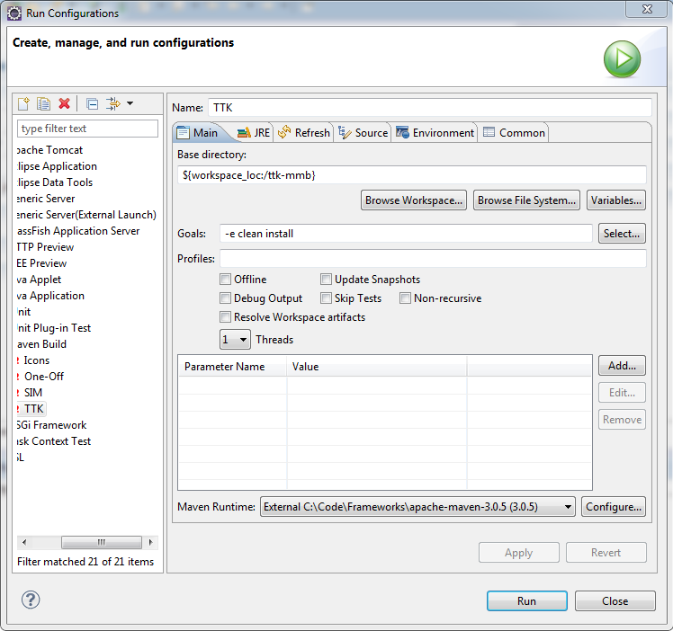

* 1. SIM Run Configuration (select maven sim project)

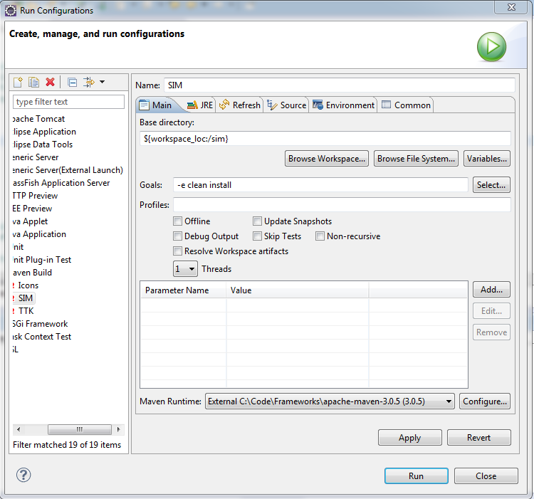

1. Build TTK
   1. If not already open, select **Run-Run Configurations** from menu
   2. Select TTK under **Maven Build**
   3. Select **Run** button
2. Build SIM
   1. If not already open, select **Run-Run Configurations** from menu
   2. Select SIM under **Maven Build**
   3. Select **Run** button

## NetBeans

## IntelliJ

## Command Line

# Install Glassfish 4.0

If already installed, skip to section Deploy SIM Rest Server

## Eclipse

1. Bring up Servers View
   1. Open Window – Open View
   2. Select Others
   3. Select Server – Servers

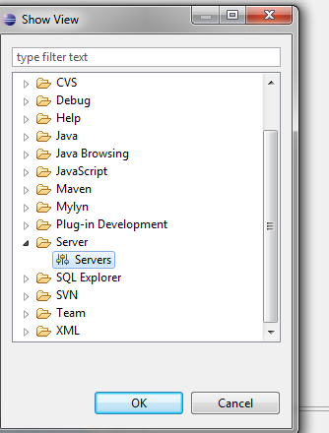

* 1. Select Servers tab

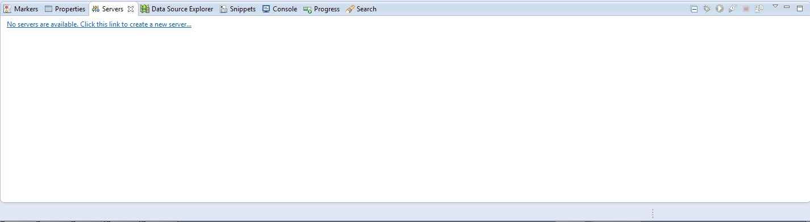

1. Create new Glassfish 4.0 Server instance
   1. Click “No servers are available. Click this link to create a new server” link

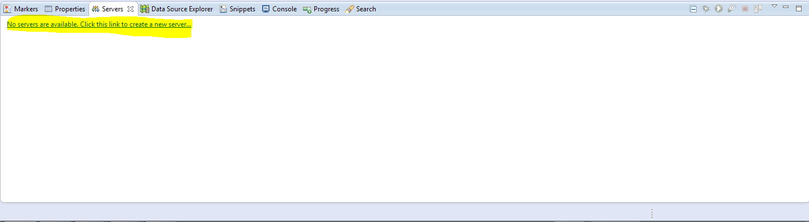

* 1. Select **Glassfish-Glassfish 4.0** option

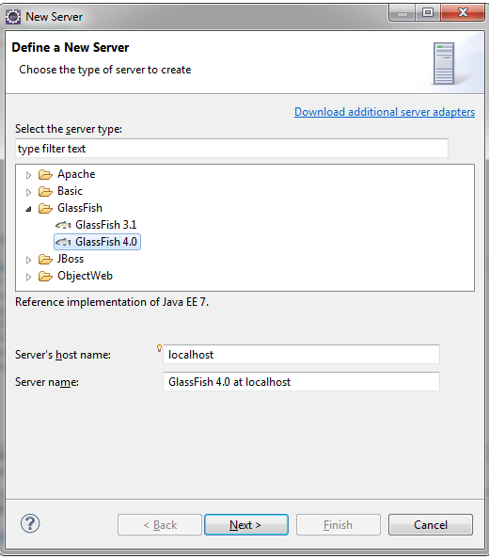

* 1. Select **Next** button
  2. Define Glassfish Runtime Directory
     1. For JDK, select one specified in workspace
     2. For Runtime Name, select any name
     3. For Glassfish Server Directory, select Glassfish 4.0 installation location
        1. If Glassfish 4.0 has already been installed in specified location, proceed to step ‘F’
  3. Install Glassfish 4.0
     1. The Dialog Box will complain that a Glassfish 4.0 installation cannot be located in the specified Glassfish Server Directory

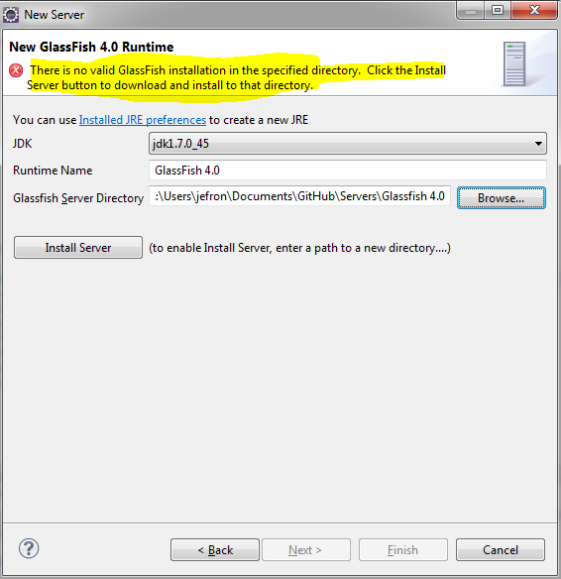

* + 1. Select **Install Server** button
    2. Select **Next** button ensuring that license is accepted
    3. Glassfish 4.0 will be downloaded and installed
  1. Configure Glassfish 4.0 instance
     1. Select Domain Directory (default is appropriate)
     2. Select Administrator Id (default is appropriate)
     3. Select Administrator Password (default is appropriate)

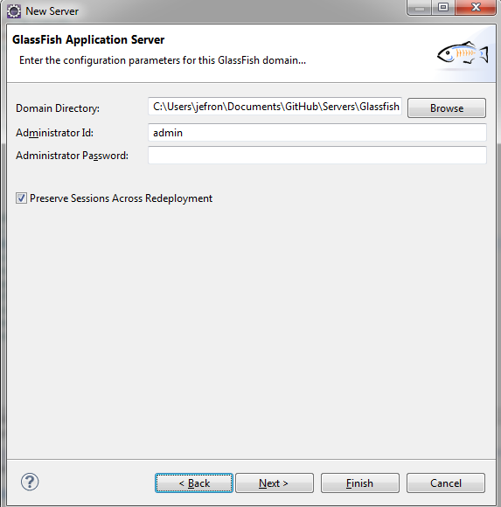

* + 1. Select **Next** button
    2. May deploy sim-rest-server at this point, but ignore for now
       1. Will present deployment at later stage
    3. Click **Finish** button

## NetBeans

## IntelliJ

## Command Line

# Deploy Berkeley Database onto Server

<To Be Completed>

# Start Glassfish Server

## Eclipse

1. Go to server panel
2. Right-Click on Glassfish 4.0 Server
3. Select Start

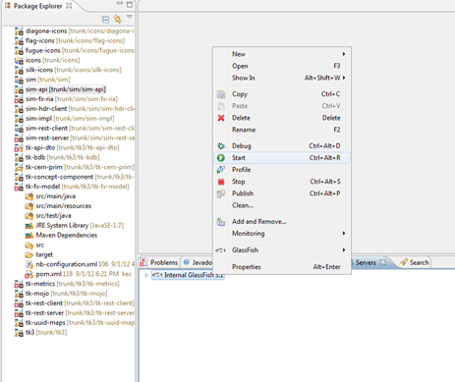

## NetBeans

## IntelliJ

## Command Line

# Configure Glassfish Properties

1. Goto Admin Console <http://localhost:4848/common/index.jsf>
2. Open **Configurations** in tree
3. Open **server-config** under Configurations
4. Select **JVM Settings under** server-config
5. Select **JVM Options** Tab

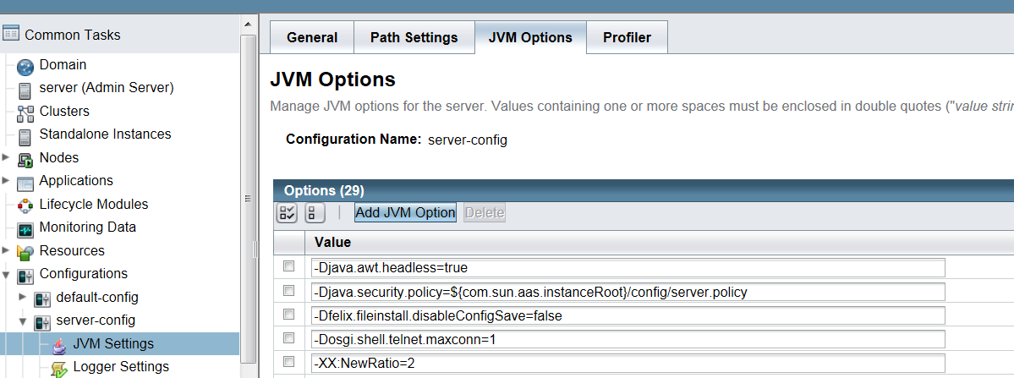

1. Change –XX:MaxPermSize variable to 512m
2. Change –Xmx variable to –Xmx1600m
3. Add JVM Option
   1. Select **Add JVM Option** button
   2. Add string “-XX:-UseGCOverheadLimit”
4. Save

# Deploy SIM Rest Server

## Via AutoDeploy

1. Goto SIM/sim-rest-server/target folder
2. Copy sim-rest-server-1.2-SNAPSHOT.war file
3. Paste sim-rest-server-1.2-SNAPSHOT.war file to:

<Glassfish Installation Home>\ domains\domain1\autodeploy folder

## Via Glassfish Administrator Web Page

1. Goto Admin Console <http://localhost:4848/common/index.jsf>
2. Open **Applications** in tree
3. Select **Deploy** button

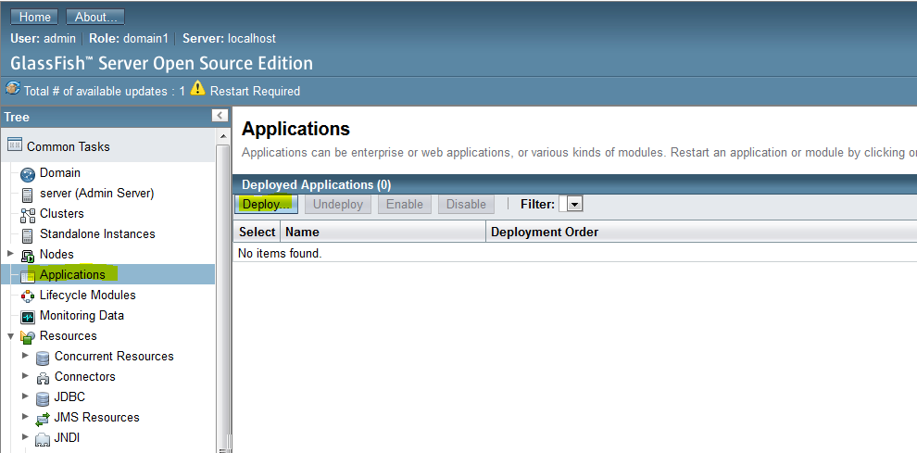

1. Select **Browse** button
2. Add the SIM/sim-rest-server/target/sim-rest-server-1.2-SNAPSHOT.war file
3. Select **OK** button

## Test Deployment

1. Open WebPage to: <http://localhost:8080/sim/>
2. Should be able to view:

